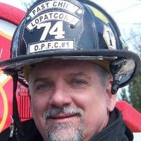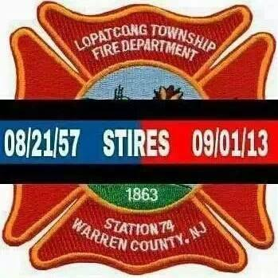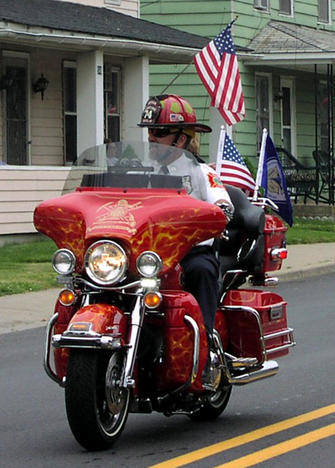

**THE BARRY L. STIRES PLAQUE DEDICATION & MOTORCYCLE RIDE**

**SEPTEMBER 6, 2014 at 1 P.M.**

**DELAWARE PARK CHEMICAL ENGINE COMPANY NO. 1**

**112 PARK AVENUE, PHILLIPSBURG, N.J. 08865**

